Key Insights and Core Concepts

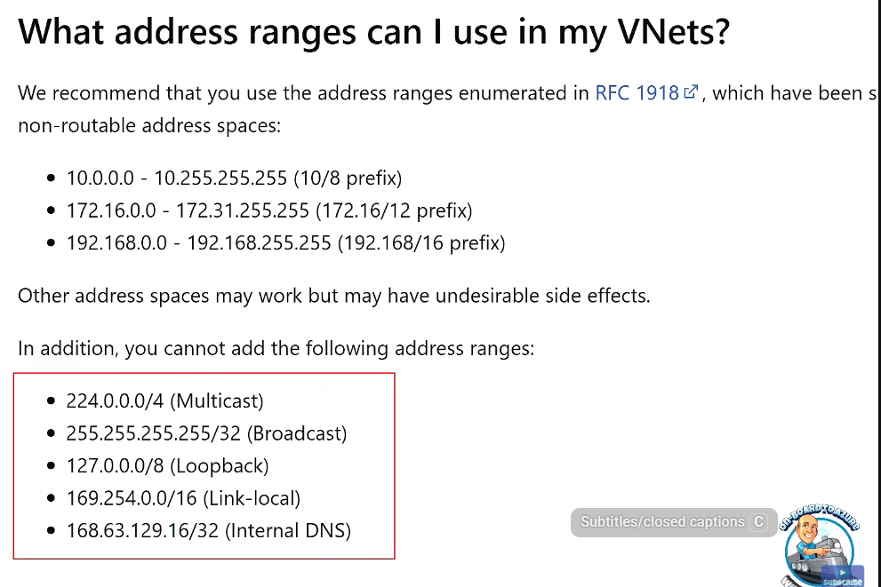
Azure Virtual Network (VNet)
- A virtual network is a regional, subscription-bound Layer 3 construct, existing only within one region and subscription.
- VNets can have multiple IPv4 CIDR address spaces (usually private IP ranges per RFC 1918), and optionally IPv6 (dual-stack only).
- VNets are subdivided into subnets, which are segments of the VNet IP space; subnets are also regional, not pinned to availability zones.
- IP ranges must not overlap within VNets or with on-premises networks to avoid connectivity issues.
- Azure uses DHCP within VNets for IP assignment; IPs can be dynamic or static per resource.
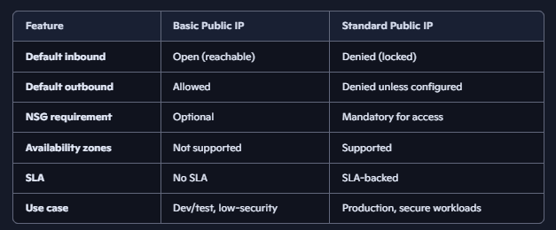
- Broadcast, multicast, GRE encapsulation are not supported; only Layer 3 IP-based protocols like TCP, UDP, ICMP are functional.

Public IP Addresses
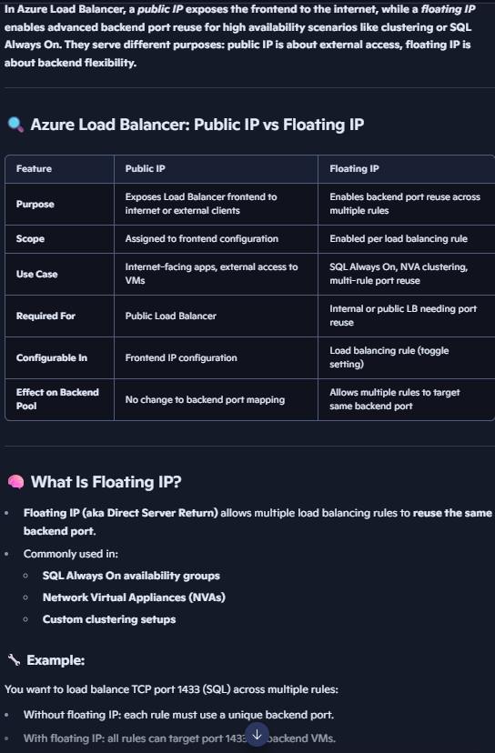
- Azure provides two SKUs for public IPs: Basic - dynamic or static, no zone support, open by default and Standard - static only, zonal, locked down by default (inbound traffic is blocked unless explicitly allowed by an NSG or Azure Firewall). Standard is more secure and for production workloads. Basic is for simple non production workloads.
- Public IPs are regional and cannot be moved between regions.
- Multiple contiguous public IPs can be allocated via Public IP Prefixes.
- Public IPs are often frontends for services, typically behind load balancers for scalability and resilience.

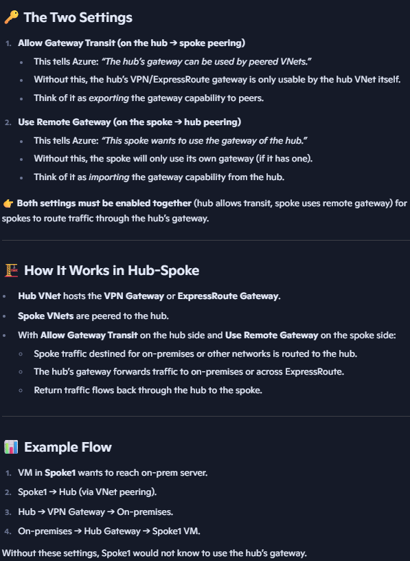
VNet Peering and Connectivity
- VNets can be connected via VNet Peering (regional or global), using Azure’s backbone network instead of VPN tunnels.
- Peering requires non-overlapping IP spaces and must be explicitly authorized in both directions.
- Peering is non-transitive; spokes peered to a hub cannot communicate unless explicitly peered or routed via appliances.
- Allow Gateway Transit and Use Remote Gateway settings allow spokes to use a hub’s VPN or ExpressRoute gateway.
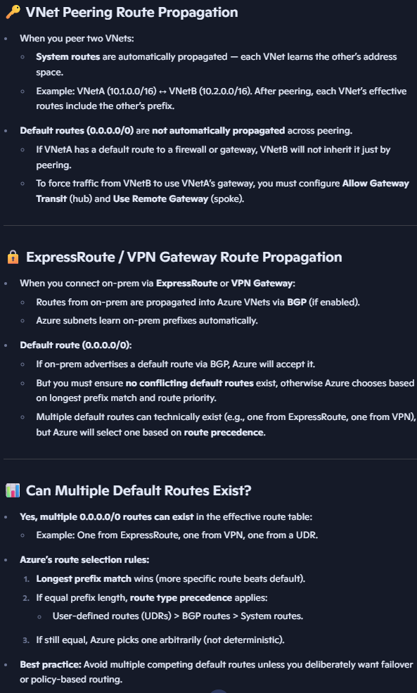
- User Defined Routes (UDRs) enable custom routing with route tables, e.g., directing traffic through Network Virtual Appliances (NVAs) when we want 2 spoke vnets to route/connect to each other. Route table can only be linked to a vnet in same region as route table.

Azure NAT Gateway
Provides outbound internet connectivity for resources in a subnet without requiring individual public IPs on each VM. Performs Source Network Address Translation (SNAT) — translating private IPs of VMs into public IPs attached to the NAT Gateway. NAT Gateway can span multiple Availability Zones in a region for resiliency. Applied at the subnet level; all outbound traffic from that subnet flows through the NAT Gateway. Tracks connections so return traffic is automatically allowed back in. Only IPv4 Public IP is supported and Dynamic IPs are not supported — must be static (upto 16 individual or contiguous IP prefix range. Supports thousands of concurrent connections per public IP, and scales with IP Prefix size. Each public IP provides a pool of 64,000 SNAT ports. NAT Gateway does not handle inbound traffic translation. For inbound scenarios, you must use Azure Load Balancer or Application Gateway. If your service already has a Load Balancer for inbound requests: Load Balancer handles inbound traffic.
NAT Gateway can still be used for outbound traffic from the same subnet, but it is not enforced by default and Load balancer can be used for outbound return traffic, so not breaking existing traffic flows.

Azure DNS
It is a hosting service for DNS domains, providing name resolution using Microsoft’s global infrastructure. It supports both public DNS zones (internet-facing) and private DNS zones (internal Vnet-scoped). DNS queries are resolved by Azure’s distributed DNS servers, ensuring low latency and high availability. By default, Azure VMs use Azure-provided DNS (168.63.129.16) for name resolution. This endpoint is always available inside Vnets. You can override the default Azure DNS (168.63.129.16) by specifying custom DNS servers at the VNet level. All VMs in that VNet will use the custom DNS servers unless overridden at NIC level.
Azure Private DNS Zones - Provide name resolution for private endpoints and internal services. You must link a Private DNS Zone to one or more Vnets. VMs in those VNets can resolve names in the zone. Resolution: Any linked VNet can resolve records in the zone. Registration: Only one VNet can be designated for automatic record registration (auto-register VM hostnames).
Public DNS Zones - Host DNS records for domains accessible over the internet. Globally resolvable by any client using Azure’s authoritative DNS servers.

Hybrid Connectivity – to another cloud or on prem
- VPN Gateways support site-to-site, point-to-site, and ExpressRoute connections.
- VPN Gateways come in Basic (legacy, limited) and Route-based (dynamic, multiple tunnels, active-active) SKUs.
- VPN tunnels have a max throughput per tunnel ~1 Gbps, but multiple tunnels can increase total bandwidth.
- ExpressRoute provides private, dedicated connections to Azure through Microsoft’s global backbone.
- Two main ExpressRoute peering types:
  - Private Peering: connects on-premises IP space to Azure VNet IP space.
  - Microsoft Peering: connects to Microsoft services (e.g., Office 365) over private paths.
- ExpressRoute circuits are redundant, active-active, with different SKUs (Standard, Premium, Local) affecting routing scope and cost.
- ExpressRoute Global Reach enables interconnecting on-premises networks via Microsoft backbone.
- Azure Virtual WAN (Azure Virtual One) simplifies hybrid network management by providing managed hub-and-spoke style connectivity with VPN, ExpressRoute, and point-to-site support.

Load Balancing Solutions
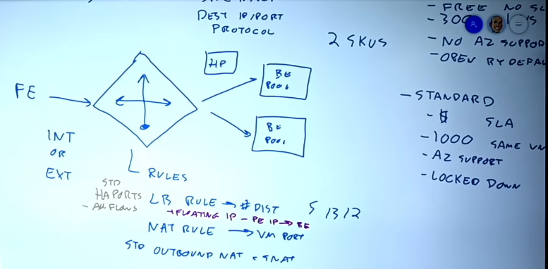
Azure Load Balancer: Regional Layer 4 (TCP/UDP). distributes traffic across healthy backend resources. Works with public IPs (internet-facing) or internal IPs (private, within Vnets). Supports Basic and Standard SKUs.
  - Basic: free, limited scale, no SLA, no zone support, open by default. 1 availability set of VM scale set.
  - Standard: zone-redundant or zonal, SLA-backed, supports IP-based backend pools, 1000 backends in same vnet, locked by default.
  - Public IP's SKU must match the SKU of the Azure Load Balancer with which it is used.
  - Features include health probes, load balancing rules, NAT rules, session persistence, and floating IP.
  - Core components:
Frontend IP configuration: The IP address clients connect to (public or private).
Backend pool: A set of backend resources (VMs, VMSS instances, NICs) that receive traffic.
Load balancing rules: Define how traffic is distributed between frontend and backend.
Health probes: Monitor backend health; only healthy instances receive traffic.
  - Types of Rules:
Load Balancing Rules - Map a frontend IP + port to a backend pool + port. Example: Frontend 80 → Backend pool 80. Distributes traffic evenly across healthy backends.
Inbound NAT Rules - Map a frontend IP + port to a specific backend VM + port. Used for direct RDP/SSH access to individual VMs behind the load balancer. Eg: Frontend 50001→VM1 3389 (RDP).
Outbound Rules - Define how outbound connections from backend pool instances use frontend IPs.
Useful for SNAT scaling (e.g., many VMs needing outbound internet access). Example: Backend pool VMs → Internet via frontend public IP.
  - High Availability (HA) Ports are a special load balancing rule type. Instead of mapping a single port, HA Ports allow all ports (0–65535) to be load balanced. Commonly used in hub-and-spoke architectures or NVAs (Network Virtual Appliances) where you want to forward all traffic from a frontend IP to a backend pool.

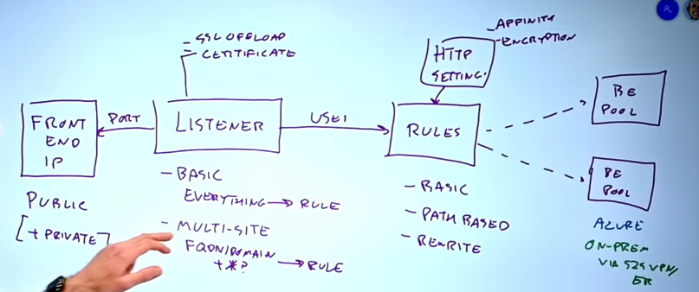
Azure Application Gateway: Regional Layer 7 (HTTP/HTTPS). Provides application-level routing (URL-based), SSL offload, cookie based session affinity, and integrates with Web Application Firewall (WAF). Supports multi-site hosting with multiple listeners on the same IP/port via hostname routing. Components:
- Listeners – It is a logical entity that checks for incoming traffic on a specific frontend IP + port + protocol (HTTP/HTTPS). Types of listeners:
Basic Listener - Listens on a single host name and port. Example: www.contoso.com on port 443.
Multi-site Listener - Allows routing based on host headers (multiple domains on same gateway).
Example: www.contoso.com → Pool A, shop.contoso.com → Pool B.
Path-based Listener - Routes traffic based on URL path. Eg: /images/* → Pool A, /videos/* → Pool B.
- Rules - define how traffic from a listener is routed to backend pools. Types of rules:
Basic Rule - Maps listener directly to a backend pool. Eg: Listener on port 80 → Backend Pool of VMs.
Path-based Rule - Routes requests to different backend pools based on URL path. Eg: /api/* → API Pool, /app/* → App Pool.
Multi-site Rule - Routes requests based on host headers (domain names). Eg: contoso.com → Pool A, fabrikam.com → Pool B.
- Backend Pools - It is a collection of backend targets that receive traffic from the gateway. Types of backend pool members:
Virtual Machines (VMs) — NICs inside a Vnet.
Virtual Machine Scale Sets (VMSS) — auto-scaling compute.
IP addresses — static IPs inside or outside Azure.
FQDNs (Fully Qualified Domain Names) — external endpoints or services.
Backend pools can mix these types, allowing hybrid scenarios (Azure + external services).
Each backend pool is monitored with health probes to ensure only healthy instances receive traffic.

Azure Traffic Manager: Global DNS-based traffic distribution service. It does not proxy or carry the traffic itself — instead, it responds to DNS queries with the “best” endpoint (IP address) based on your chosen routing method. Because it works at the DNS layer (Layer 7 name resolution, but not packet forwarding), the client connects directly to the chosen endpoint after DNS resolution. Azure Traffic Manager supports several routing methods:
Priority Routing - Directs all traffic to a primary endpoint unless it becomes unhealthy. Failover to secondary endpoints when needed. Use case: Active-passive disaster recovery.
Weighted Routing - Distributes traffic based on weights you assign (e.g., 70% to Endpoint A, 30% to Endpoint B). Use case: Gradual migration, A/B testing.
Performance Routing - Routes clients to the endpoint with the lowest latency (based on DNS query location vs Azure region performance). Use case: Global applications needing best user experience.
Geographic Routing - Routes traffic based on the geographic location of the DNS query origin. Use case: Data sovereignty, region-specific content.
Multivalue Routing - Returns multiple healthy endpoints in DNS response. Clients can pick one, providing resilience. Use case: Simple round-robin with health awareness.
Subnet Routing - Routes traffic based on the client’s IP address range (subnet mapping). Use case: Directing specific user groups or corporate ranges to dedicated endpoints.

Azure Front Door: Global Layer 7 (HTTP/HTTPS) application delivery network. Provides global load balancing, acceleration, SSL offload, caching, and security (WAF). Built on Microsoft’s global backbone network, not the public internet, ensuring low latency and high reliability. When a client makes a request, DNS resolves the application’s hostname to the nearest Front Door POP (Point of Presence).
Traffic enters Microsoft’s private backbone network at that POP. From there, it is carried across Microsoft’s optimized routes to the backend service (Azure or on-prem). This avoids unpredictable internet routing, giving consistent performance worldwide. Front Door uses Anycast IP addressing:
A single global public IP is advertised from all POPs worldwide. Clients automatically connect to the closest POP (based on BGP routing). This ensures low latency and resilience — if one POP fails, traffic is automatically routed to another. Split TCP acceleration is used to optimize long-haul connections:
The client establishes a TCP connection with the nearest Front Door POP. The POP then establishes a separate TCP connection to the backend service. This reduces latency by shortening the client’s TCP handshake distance. Front Door includes edge caching: Static content (images, scripts, files) can be cached at POPs. Reduces load on backend servers and improves response times for clients. Works like a CDN but integrated with load balancing and acceleration.
- Front Door V2 (preview) adds private link support, bot protection, and CDN integration.

Network Security and Access Control
Network Security Groups (NSGs):
  - Applied at subnet or NIC level; they filter inbound/outbound traffic based on 5-tuple (source/dest IP, port, protocol). Built-in rules allow VNet traffic and Azure load balancer probes by default.
Service Tags simplify management by abstracting IP ranges for Azure services (e.g., Storage, VirtualNetwork).
Application Security Groups (ASGs) provide logical grouping (tags) of NICs to simplify NSG rules.
Service Endpoints: Extend VNet identity to Azure services, creating optimized routes and allowing firewall rules based on VNet/subnet.
Private Endpoints (Private Link): Assign private IP addresses from VNet to Azure services, enabling private connectivity without public exposure.
  - Requires DNS configuration to resolve service names to private IPs.
  - Supports custom services via internal Standard Load Balancer and Private Link Service.
“App Service Plan” (compute resources that host your App Services like Web Apps, APIs, Functions) can make outbound calls into a VNet (e.g., to reach databases, APIs, private endpoints) using a “Regional VNet Integration”. For inbound traffic to app service from a vnet, private endpoint used.
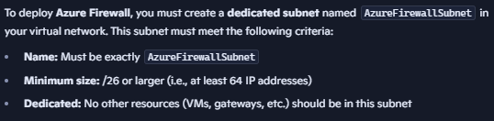
Azure Firewall:
  - Deployed in dedicated subnet, stateful, scalable firewall service.
  - Two SKUs: Standard and Premium.
  - Premium adds TLS Inspection, Intrusion Detection/Prevention (IDPS), URL filtering with web categories.
  - Supports network rules (Layer 4; 5 tuples), application rules (Layer 7 ; FQDN/URL), and DNAT rules.
  - Integrated with policies for centralized management.
Distributed Denial of Service (DDoS) Protection:
  - Basic protection is inherent.
  - Standard offering provides ML-based adaptive protection and advanced monitoring.

Monitoring and Diagnostics
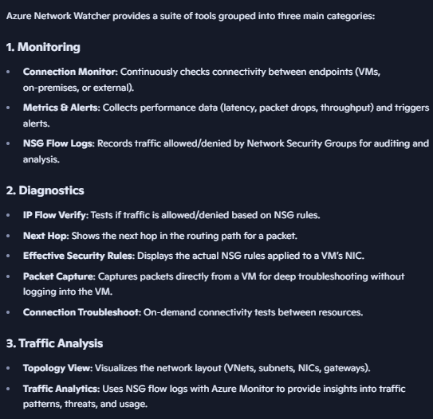
- Azure Network Watcher built-in monitoring and diagnostic service for Azure networking. It helps you track, troubleshoot, and analyze traffic flows, connectivity, and performance across virtual networks, VMs, load balancers, VPNs, and application gateways. Provides topology visualization, connection monitoring, packet capture, NSG flow logs, and traffic analytics. Enabled automatically when you create/update a VNet in a region.
- Effective Routes and Security Rules can be viewed per NIC for troubleshooting.
- NSG flow logs capture IP flow data to storage and Log Analytics for detailed network traffic analysis.

Definitions and Comparison Table: VPN Gateway SKUs
Feature | Basic (Legacy) | Route-Based (Gen1/Gen2)
Tunnel type | Policy-based (Static) | Route-based (Dynamic)
Number of tunnels | Single | Multiple (N tunnels)
ExpressRoute coexistence | No | Yes
Point-to-site VPN support | No | Yes
Active-active support | No | Yes
BGP support | No | Optional
Zone redundancy | Varies | Generally supported
Throughput per tunnel | ~1 Gbps | ~1 Gbps

